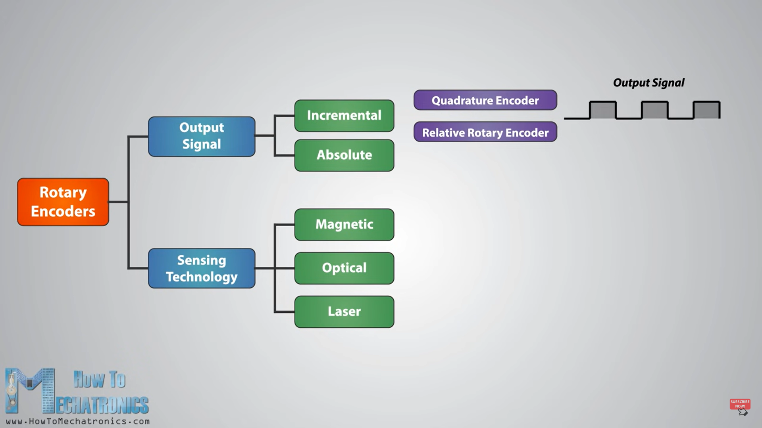

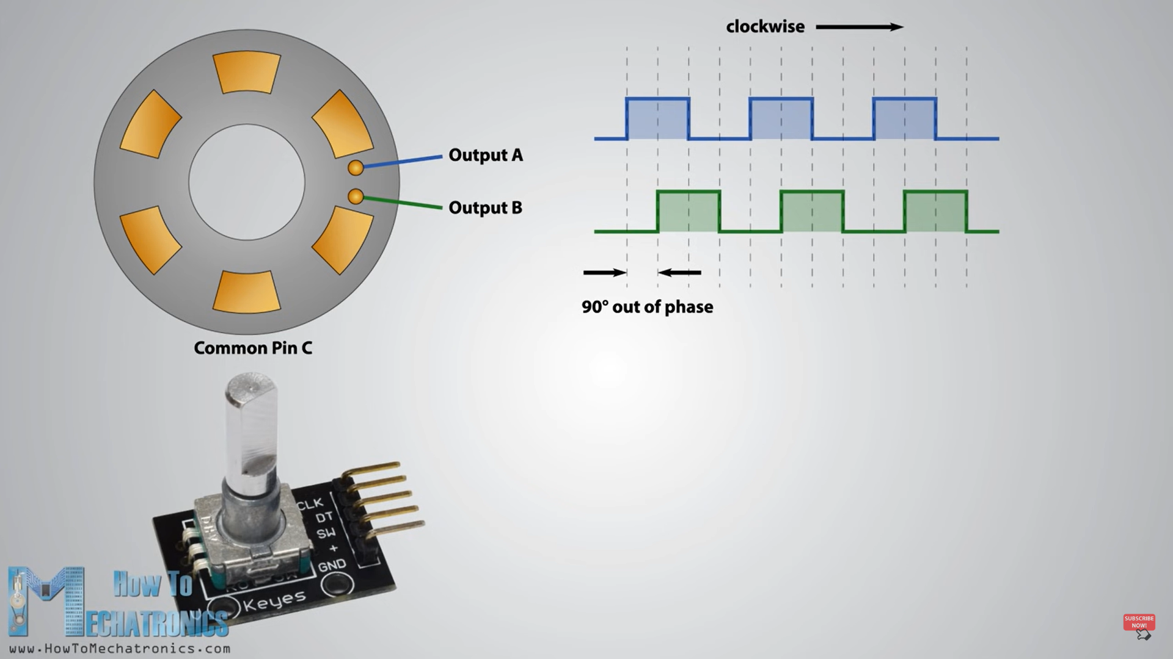

DURING CLOCKWISE ROTAION OUTPUT A IS AHEAD OF OUTPUT B BY 90 DEGREE PHASE SHIFT.

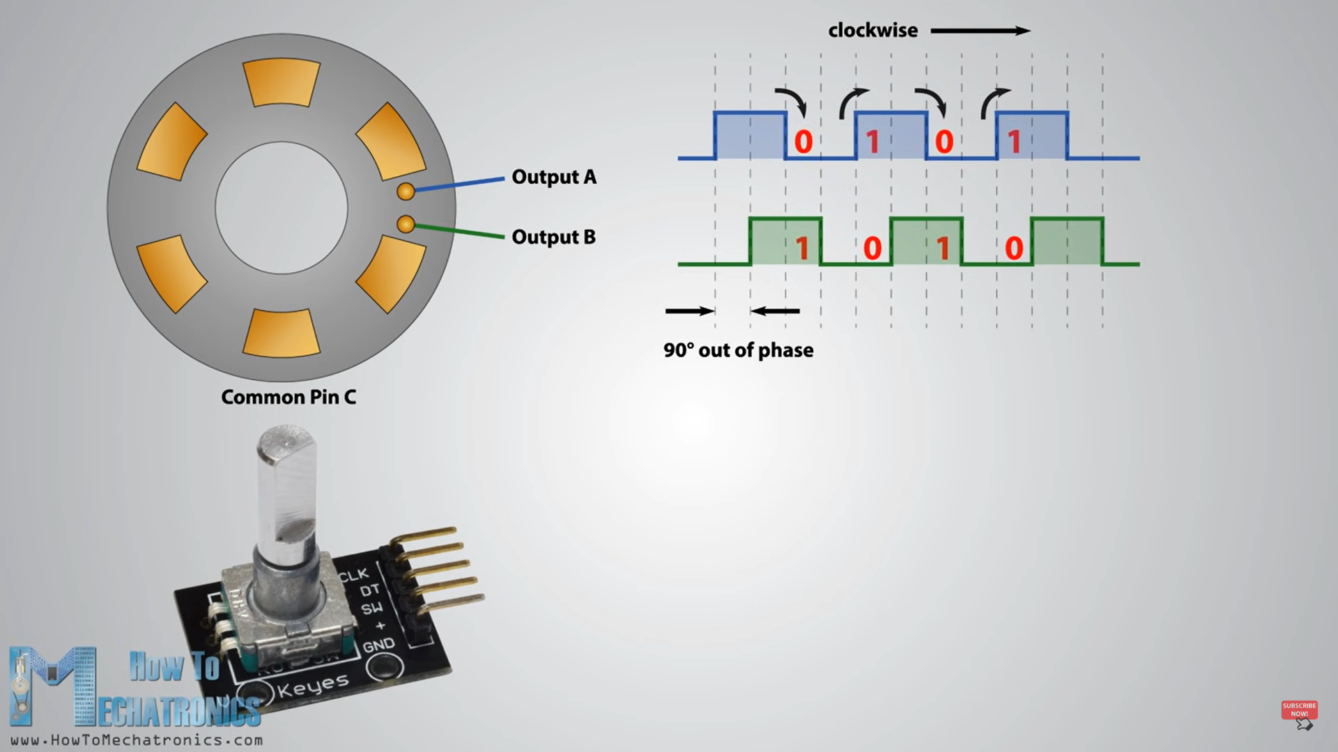

* IN CW WHEN EACH TIME SIGNAL CHANGES HIGH-LOW OR LOW-HIGH AT THAT TIME 2 OUTPUT HAS DIFFERENT VALUES ( DT != CLK )

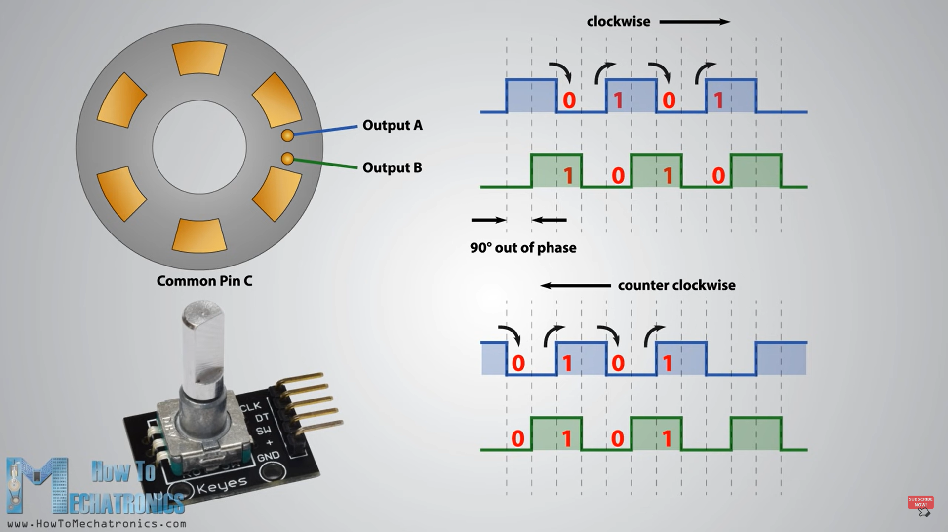

* BUT DURING CCW BOTH HAVE SAME VALUE( DT == CLK)

|  |  |
| --- | --- |
| **CW** | **CCW** |
| **( DT != CLK)** | **( DT == CLK)** |

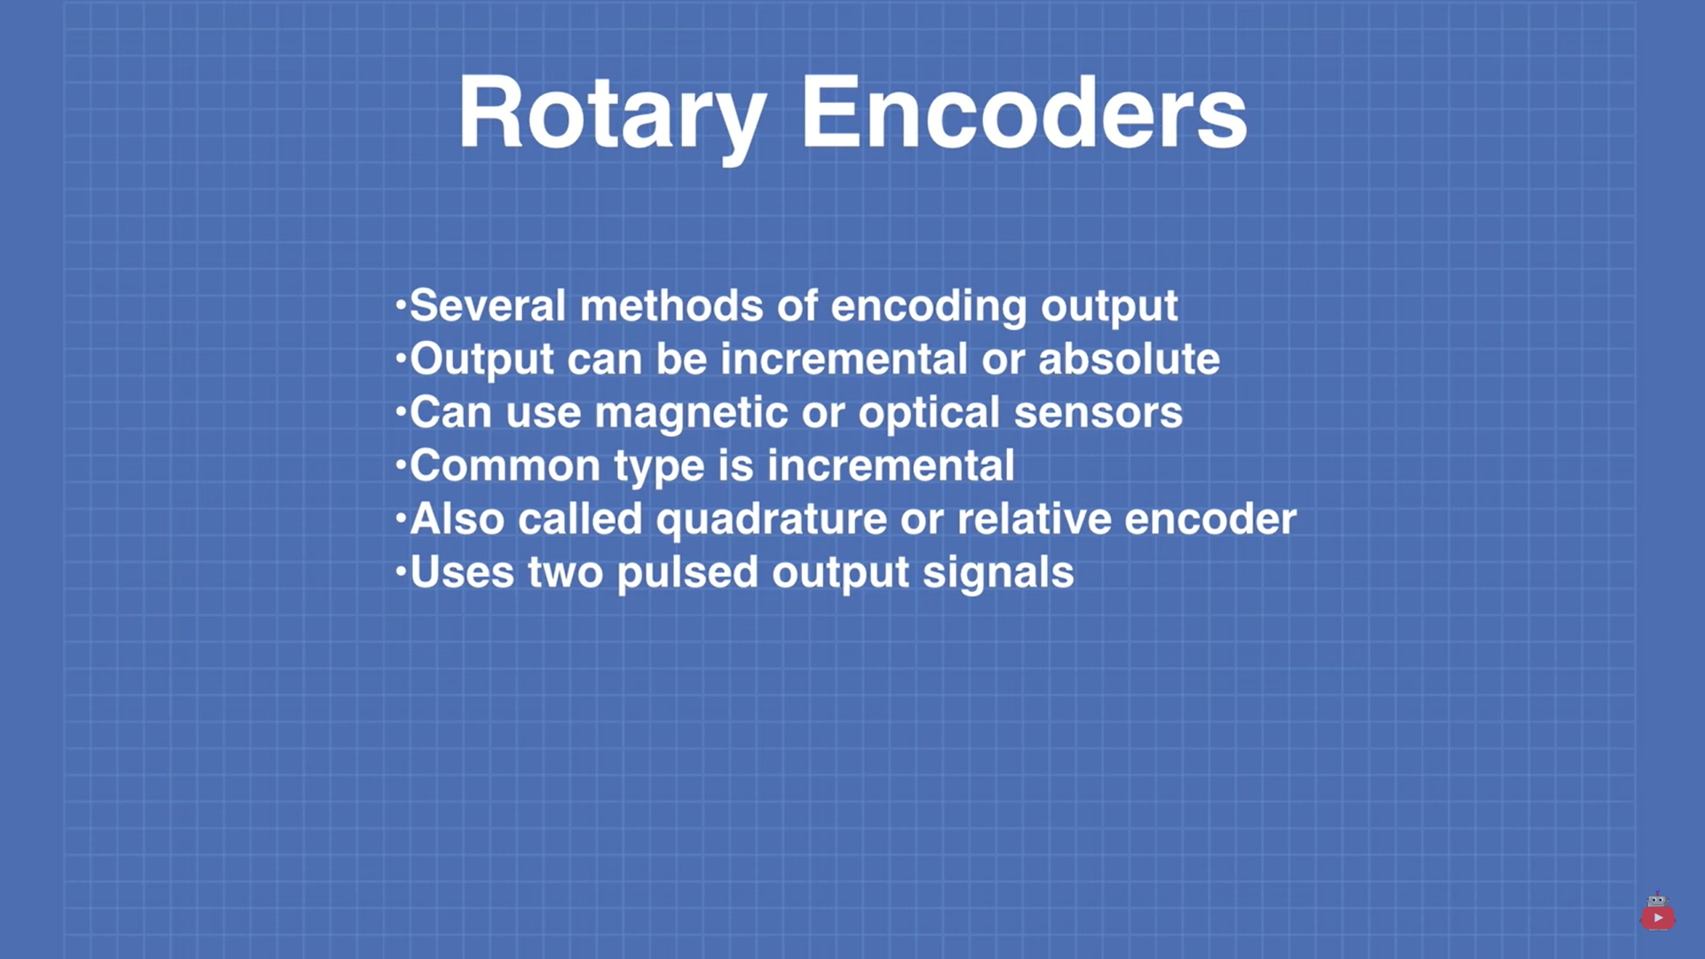

* THERE ARE 2 PARTS IN ENCODER USED:

1. Simply Encoder
2. Encoder on back of the Motor
3. Simply encoder connection with Arduino:

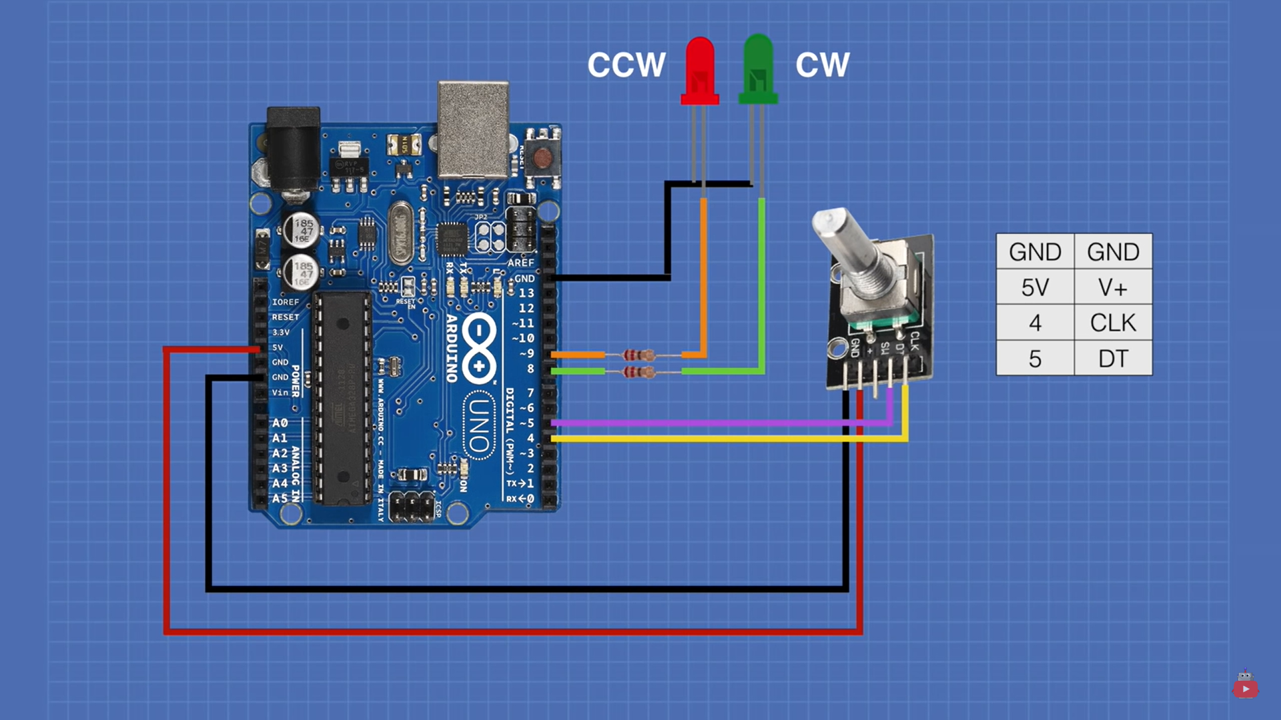

Encoder`s:

* DT(chanal A) connected with 5 pin of Arduino
* CLK(chanal B) connected with 4 pin of Arduino
* GND connected with ground pin of Arduino
* VVC connected with +5v pin of Arduino
* GREEN LED indicate clockwise rotation
* ORANGE LED indicate counter clockwise rotation